PROJECT IN AUTOMATA AND LANGUAGE THEORY

GENDER NEUTRAL LANGUAGE RECOGNIZER

Submitted by:
John paul gamo
Leona faye kapuno
Bridge ann auditor
Analyn c. omac
BSCS 3B

Submitted to:

ALMA MAE B. AUXTERO
Instructor

Date submitted [Date]

1 Project overview

NeutralScan is a web-based application that detects gender-specific terms used in the text and gives suggestions for gender-neutral terms. The main goal of this application is to encourage inclusive language by helping users to identify terms that may be biased in the documents. The application allows users to upload .txt files or paste text directly into the system. It uses regular expressions to detect predefined terms, count their occurrences, and display suggested alternatives.

2 Tools and recognition approach
Programming Languages and Tools
- HTML5 – Structures the application interface.
- CSS3 – Designs the layout and responsive appearance.
- JavaScript – Handles file uploads, text analysis, term recognition, and result display.
- Visual Studio Code – Used for writing and editing the source code.
- Web browser – Runs the application.
Recognition Approach
NeutralScan uses regular expressions to detect predefined gender-specific terms. Each term is escaped to ensure special characters are treated literally, and then converted into a regular expression.
The main pattern used is:
The pattern uses:
- g (global): Finds all occurrences of a term in the text.
- i (case-insensitive): Recognizes terms regardless of capitalization.
- u (Unicode): Supports Unicode character matching.
- Unicode-aware boundaries: Prevent matching a term when it is part of a longer word.

For example, the term he matches he, He, and HE, but does not match the.

List of Gender-Specific Terms and Suggested Alternatives
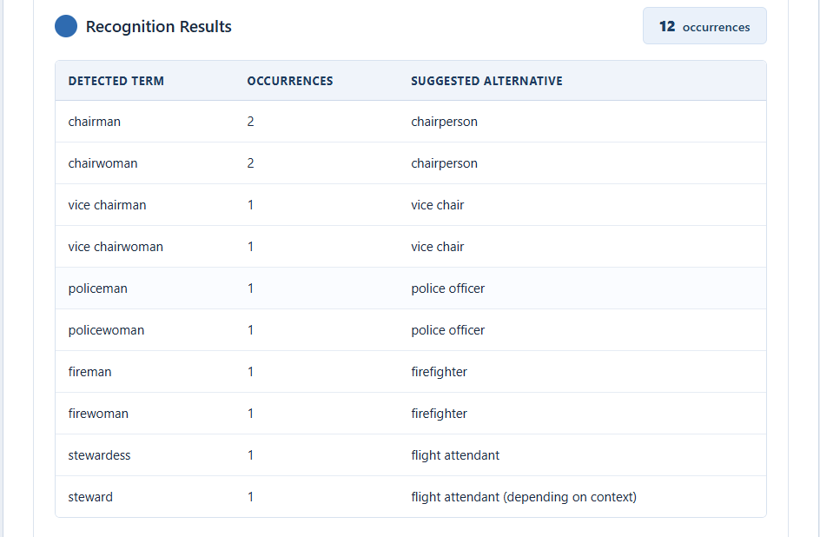

3 Application screenshots
The screenshots below were captured from NeutralScan while using the supplied sample test documents. This application opens with three panels: text input, recognition results, and an explanation of the matching method.
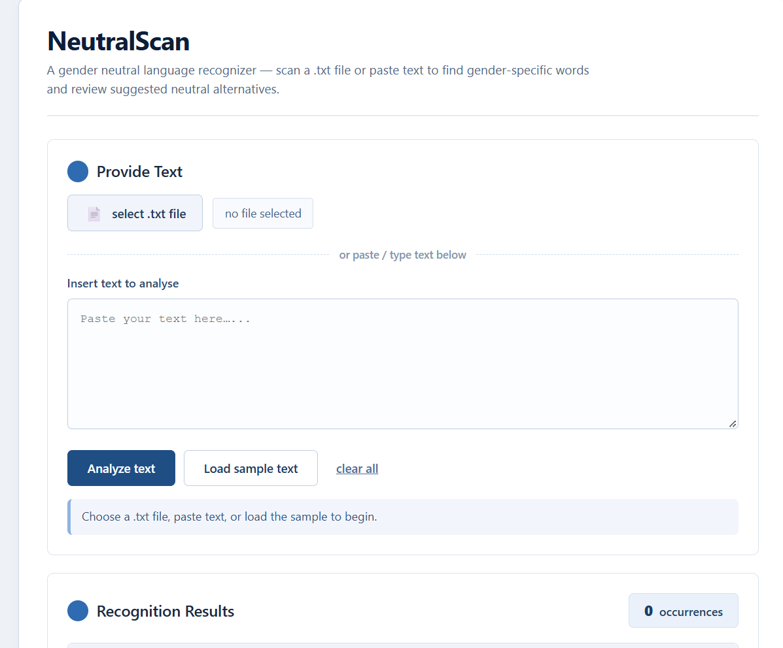

Figure 1: The NeutralScan main interface before any text is loaded.
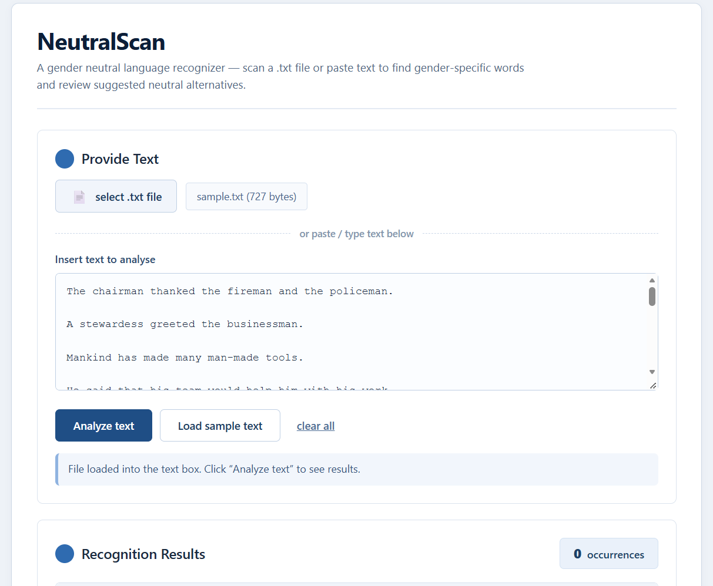
Figure 2: Sample text loaded into the input box, ready for analysis.

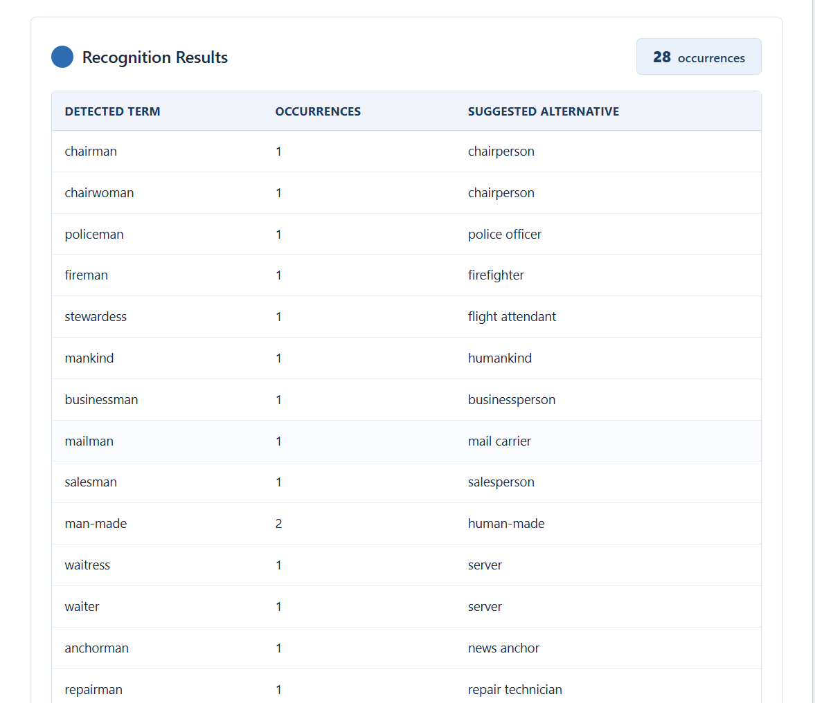

Figure 3: Results table for the sample text, showing detected terms, occurrence counts, and suggested alterbatives.

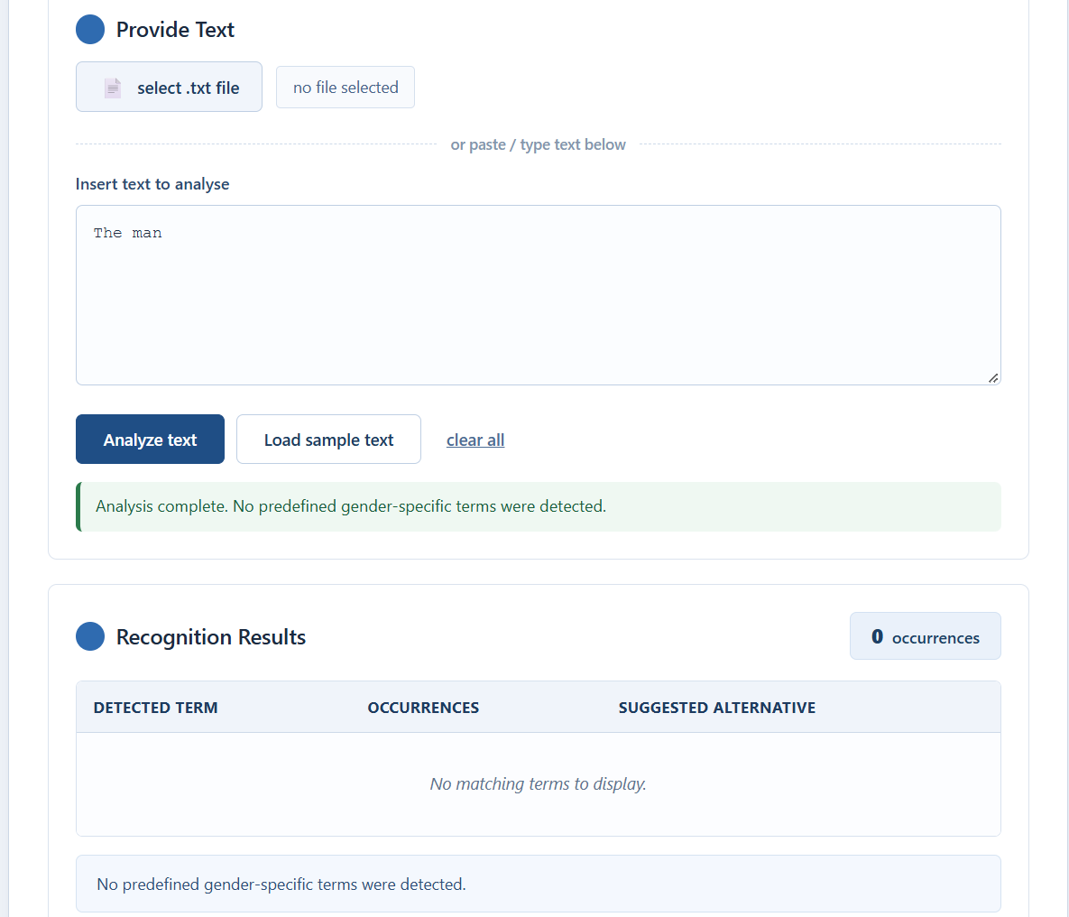
Figure 4: The application after analyzing text with no matching terms.

Source code: Included with the downloadable project ZIP. PUBLIC REPOSITORY LINK:

https://github.com/Paul3-24/Gender-Neutral-Language-Reader.git

4. Testing
The five instructor-required situations were tested manually against the final NeutralScan recognizer and document reader. The sample text file and the error-handling cases were run directly in the browser application, and the results were recorded for the screenshots above. The recognizer passed all five test cases: detection of listed terms, repeated terms with mixed capitalization, a no-match text that includes “the” (confirming it does not trigger “he”), an empty .txt file, and an unsupported file format.

Test case | Expected result | Actual verified result | Status
1. Listed terms | Identify supplied gender-specific terms | 13 distinct / 14 total | PASS
2. Same term repeated, different capitalization | repeated, ex: Fireman, fireman, FIREMAN, FireMan, fireman | Fireman = 5 | PASS
3. No terms / “the” | Zero matches: the does not trigger he | 0 matches; no false positives | PASS
4. Empty TXT file | Clear empty-file message | Message shown, no crash | PASS
5. Unsupported file | Clear unsupported-format message | Message shown, input reset | PASS

To reproduce: open index.html in a modern browser, then load the labeled files from the samples/ folder (sample.text) or click Load sample text to try the included sample. The file reader accepts plain-text .txt files only; .docx and .pdf files are rejected with an unsupported-format message, as specified in the project scope.

5 Conclusion

NeutralScan was developed to recognize gender-specific terms and suggest gender-neutral alternatives using regular expressions. With this project, we applied principles from Automata Theory and Formal Languages to a practical text-processing application. We learned how to implement case-insensitive matching, whole-word matching, file manipulation, and word-frequency counting. The current limitations of this application include that it can only handle plain-text files and requires a pre-defined vocabulary.

6 Sources and contributions
Tools: HTML5, CSS3, and JavaScript, with MDN Web Docs as the primary reference for regular-expression and FIle API features. The project uses an original, rule-based recognition approach built on JavaScript regular expressions. The BISU machine-problem guide supplied the requirements and test situations.

Contributions: The student group designed the term list, built the interface, wrote the matching and counting logic, tested the five required situations, and prepared this report. OpenAI ChatGPT assisted with code generation, UI suggestions, debugging, sample test creation, and drafting. The group is responsible for reviewing and verifying the final submission.

